


Public perceptions research

March 2023


Contents page

Contents Page

Contents page

Contents Page

Contents page 1
Project details 2
Executive summary 3
Research objectives and methodology 7
Public perceptions of opticians / optometrist practices 9
Using the services provided by an opticians / optometrist practice 11
Satisfaction with sight test / eye examination 15
Adverse experiences and complaints 19
Trust and confidence 23
Shopping around 24
Knowing the price ahead of the appointment and purchasing glasses / contact lenses 27
Appendix A: Sample profile 33
Appendix B: Questionnaire 34

Project details

Title | Public Perceptions Research 2023
Client | General Optical Council
Project number | 20189
Author | Kirsty Marshall and Katherine Atkinson

M·E·L Research Ltd
Somerset House, 37 Temple Street, Birmingham, B2 5DP
Email: info@melresearch.co.uk
Web: www.melresearch.co.uk
Tel: 0121 604 4664

Executive summary
Based on a UK representative sample of 2,020 interviews which were completed online between 27 January until 13 February 2023, the headline messages for the General Optical Council are summarised below.
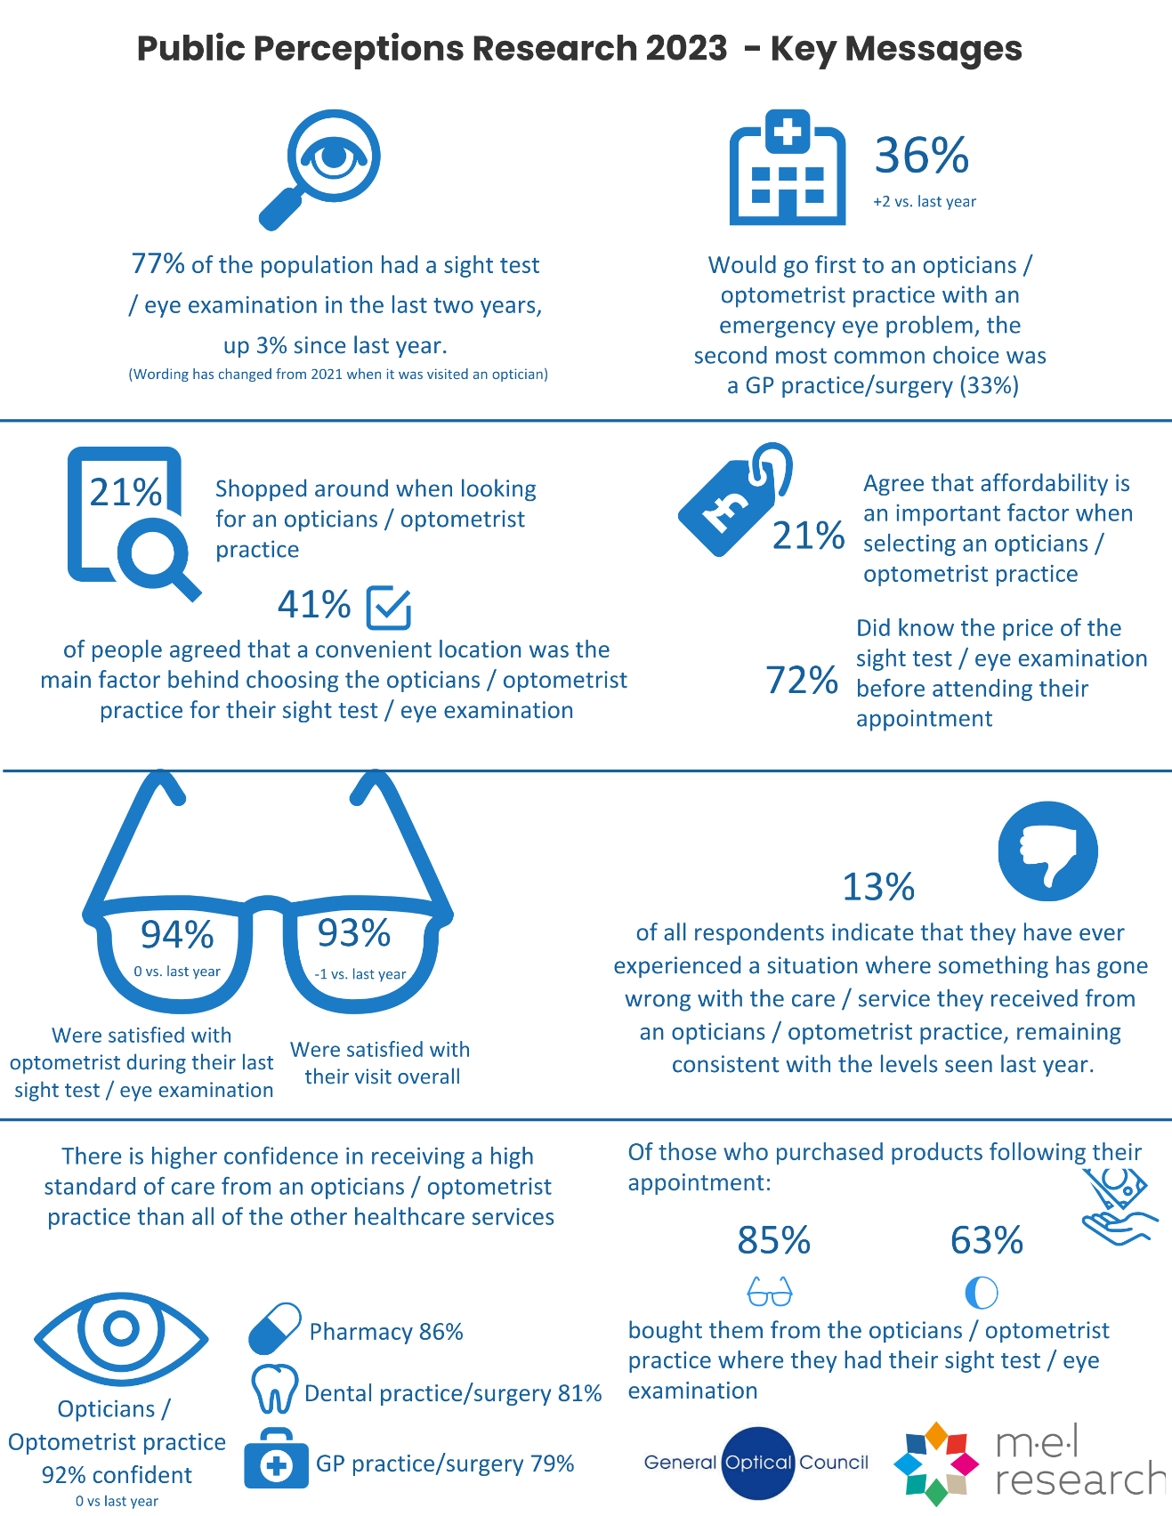
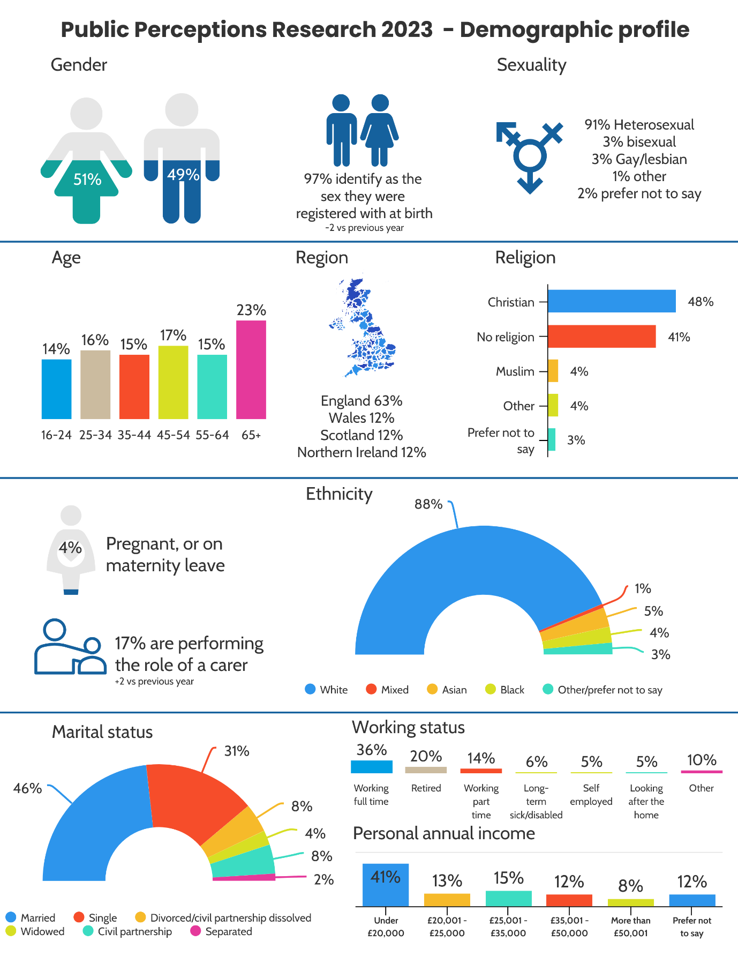
Perceptions and service experiences
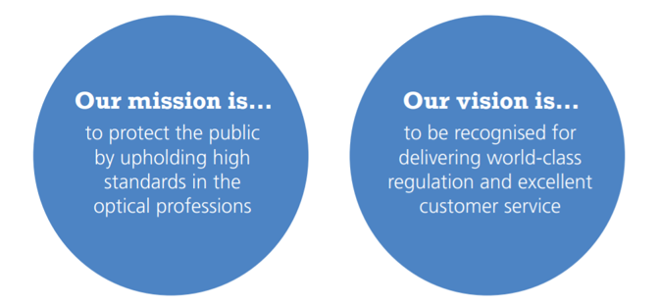
Key findings
The mission of the General Optical Council (GOC) is to protect and promote the health and safety of the public by upholding high standards in the optical profession. This regulatory function is being delivered across a sector that the public continue to view in a highly positive manner:
- Public satisfaction levels - The high level of public satisfaction with optometrists who carry out sight tests / eye examinations that has been evident in previous iterations of this research has been sustained into 2023. More than nine in ten individuals (94%) who have had a sight test / eye examination within the last two years state that they were satisfied with the optometrist who carried this out. This is in line with the result seen last year, where satisfaction levels were 94%. (N.B., both sight test and eye examination are included in the wording as in Scotland they use the term eye examination.)
- Satisfaction with the overall experience - Echoing the satisfaction levels (above) for the optometrist who carried out the sight test, 93% of those who had a sight test / eye examination during the last two years were satisfied with the overall experience. This is a small drop from the level of satisfaction seen in 2022 (94%), although this isn’t statistically significant. Over three quarters (80%) of respondents who had had a sight test / eye examination within the last two years were also satisfied with the overall value for money.
- Public confidence in opticians / optometrist practice - Public confidence remains strong. Nine in ten respondents (92%) are either fairly or very confident in the standard of care that is provided by opticians / optometrist practices. The confidence is higher than seen in other healthcare professionals, with confidence in GP practices/surgeries fallen significantly compared to last year (79% cf. 86%), as has confidence in dental practices/surgeries (81% cf. 88%).
- Perceptions of opticians / optometrist practices - Perceptions of opticians / optometrist practices as healthcare providers have seen some improvements in the last year, with an increasing proportion likely to attend an opticians / optometrist practice as their first port of call if they woke up with an eye problem. This figure has risen from 34% in 2022 to 36% in 2023 and has now, for the first time, overtaken the proportion who would speak to their GP practice/surgery first (33%, decreasing from 35% seen in 2022, and from 38% in 2021). The long-term trend for those who would go to or speak to an opticians / optometrist practice has also increased each year since 2015 and is now at the highest levels seen (19% in 2015, 36% in 2023).
- Negative experiences when visiting an opticians / optometrist practice - There has been no change this year in the incidence of something going wrong with care/service received by patients at an opticians / optometrist practice compared to 2022. 13% report experiencing such an event in both 2023 and 2022. The proportion who received an apology (of those who have experienced a situation where something has gone wrong) was also in line with results seen last year (56% cf. 58%).
- Levels of shopping around – One in five (21%) respondents shopped around to compare different opticians / optometrist practices before picking which one to go to. Having a convenient location (41%), seeing the same healthcare professional as previous tests (25%) and an affordable price (21%) were the top three factors when choosing the provider for their sight test / eye examination.
- Knowing the price ahead of the appointment and purchasing glasses / contact lenses - Seven in ten (72%) knew the price of their sight test / eye examination before attending their appointment, with three quarters (75%) finding it easy to find the price out. Around a third (30%) knew the price already from previous visits. 70% bought either glasses or contact lenses as a result of their sight test / eye examination, with 85% of those purchasing their glasses in the same place they had their test, and 63% of those who bought contact lenses buying them from where they had their test.

Research objectives and methodology
Research background and objectives
The GOC is the regulator for the optical professions in the UK. The mission of the GOC is to protect the public by upholding high standards in the optical professions. The GOC currently registers around 33,000 optometrists, dispensing opticians, student opticians and optical businesses. As part of the organisation’s research programme which seeks to help understand the views and experiences of members of the public across the UK. The GOC first commissioned research into public views in 2015. In 2021 the GOC updated its approach to public research and this report represents the third iteration of that approach.
The key objectives of the 2023 public perceptions survey were to:
- conduct a survey with a robust and representative sample of the UK adult population (16+) including a mix of both patients and non-patients.
- measure and track trends in perceptions and levels of awareness over time, comparing results to previous years.
- collect further data on who answered the survey, including protected characteristics such as religion, marital status, and disability status.
Methodology
The 2023 survey was redesigned jointly by M·E·L Research and the GOC to ensure that the survey content remained aligned with the GOC’s strategic objectives and that it reflected the practical experiences the public will have had of using eyecare services throughout 2022.
A copy of the questionnaire can be found in Appendix B. Interlocking quotas were set to ensure a representative sample was achieved based on gender and age within each UK nation. Scotland, Wales, and Northern Ireland were over-sampled to ensure that confident statistical analysis could be undertaken by nation. The survey was hosted online and distributed to a UK consumer panel, which includes members of the public who have signed up to take part in online research on a wide number of topics. This approach replicates the approach used in the last two waves of this research delivered in 2021 and 2022. Earlier waves prior to 2019 used a mixture of telephone and online techniques.
In total 2,020 interviews were completed, exceeding the 2,000-interview target set. The distribution of these interviews per nation is shown in the figure below.
Figure 1: Sample achievement by nation
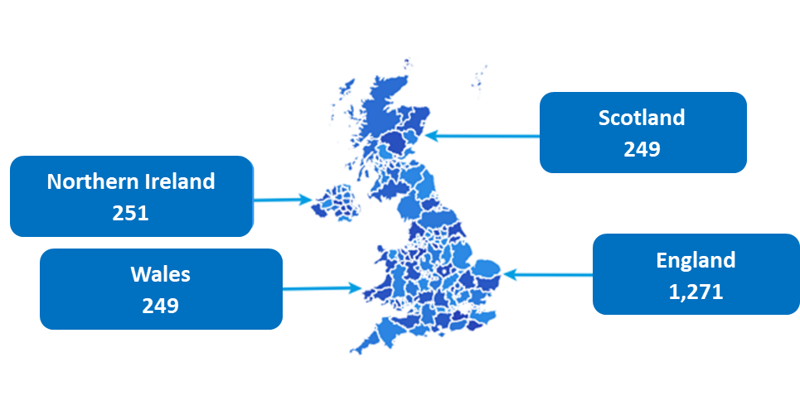
A full sample profile by nation can be found in Appendix A. Prior to the application of weighting, the survey included:

1,596 who are either glasses or contact lens wearers (79%)
1,559 who’ve had a sight test in the past two years (77%)

The 2023 dataset also includes further information on the online panel members. These variables are:
- Age, gender, region, gender reassignment, sexuality, disability, pregnancy, ethnicity, marital status, those with carer responsibilities, religion, working status, income, those with an eye condition.
All the questions of a more sensitive nature had the option to select prefer not to say, with income receiving 12% selecting prefer not to say, all other demographic questions received 3% or less selecting this option.
It’s important to note that 41% of the sample were in the lowest income bracket (under £20,000 for their personal annual income before tax), with those retired (65+) and those under 16-24 more likely to be within the lowest income band.
As the online survey was undertaken with a sample of the public, all results are subject to sampling tolerances. For example, when interpreting the results to a survey question which all respondents answered, where 50% responded with a particular answer, there is a 95% chance that this result will vary by no more than +/- 2.18 percentage points had the result been obtained from the entire UK population (16+). Sampling tolerances are higher for the smaller subgroup populations such as Northern Ireland, Scotland, and Wales. Each of these nations has a 95% confidence interval level of +/- 6.2 percentage points, with England having a 95% confidence interval level of +/- 2.75 percentage points.
Analysis and reporting
Weights have been applied to the returned data to ensure that certain subgroups are not over or under-represented within the data, and that the data is as close to the demographic profile of the UK as possible in terms of gender and age. Weighting adjusts the proportions of certain groups within a sample to match more closely to the proportions in the target population. Minor weighting corrections were applied by age and gender within each nation.
When setting the survey quotas, it was decided that the nations of Scotland, Wales and Northern Ireland should be over-sampled to allow for confident data analysis at a nation-specific level and to allow confident analysis between countries.
Statistical tests
To provide further insight into the results, we have carried out sub-group analysis by different demographics and some other variables (e.g., when their last sight test / eye examination was and current use of glasses and contact lenses). The results for these sub-groups have been presented only where they are statistically significant (at the 95% confidence level) and if the base sizes are 30 or more. Where there is a statistically significant difference between groups, this has been noted in the report as a “significant” difference.
Presentation of data
Throughout this report, those who took part in the survey are referred to as ‘respondents’. For this report, those who reported having a sight test / eye examination in the last two years are referred to as ‘patients’. Those who reported having a sight test / eye examination more than two years ago or never are referred to as ‘non-patients’.
The questions were updated last year to reflect the difference between optometrists and dispensing opticians, the two distinct optical professions the GOC regulates. This was done by splitting out certain questions into different codes or including both codes in the answer to not impact on trended data.
Owing to the rounding of numbers, percentages displayed on graphs may not always add up to 100% and may differ slightly to the text. The figures provided in the text should always be used as the authoritative results. Where shifts are shown, these have been calculated on the figures rounded to the nearest whole number.

Public perceptions of opticians / optometrist practices
The role of opticians in treating eye problems
The proportion of respondents who state that they would first go to or speak to an opticians or optometrist practice if they woke up with an eye problem has continued to grow year on year, having risen from 30% in 2021, 34% in 2022 to 36% in 2023. This figure has been steadily growing since 2015, when 19% reported, they would go to an opticians first. However, it should be noted that in 2022, the wording of this option was altered from “optician” to “An opticians / optometrist practice”, which may have impacted on the proportion who selected it in 2022 and in 2023 results.
As the proportion who would first go to an opticians / optometrist practice with an eye problem has increased, there has been a concurrent decline in the proportion who would first go to a GP since 2015, when 54% reported that they would do so. Although this figure saw a slight spike in 2021, when it rose to 38%, it has continued to fall again, with this year the first time that the proportion who would go to an opticians / optometrist practice overtaking the proportion who would go to a GP practice/surgery first.
Figure 2: If you woke up tomorrow with an eye problem, such as something in your eye, a red eye or blurred vision, where would you go or who would you speak to first? (All respondents)

Unweighted sample base: 2023 (2,020) / 2022 (2,234) / 2021 (2,087) / 2019 (2,000) / 2017 (3,025) / 2016 (3,252) / 2015 (2,250)
*Answer option changed from “An optician” to “An opticians / optometrist practice” in 2022
Among patients (those who have had a sight test / eye examination in the last two years), the proportion who would go to an opticians / optometrist practice first if encountering an eye problem is significantly higher (39%) than the proportion of non-patients (23%) who would do so. 32% of patients were likely to go to a GP practice first, whilst the figure for non-patients was 37%.
At the nation level, respondents in Northern Ireland (49%) and Scotland (46%) are significantly more likely than those in the overall sample to go to an opticians / optometrist practice first, while respondents in England are less likely to (30%). (39% for those living in Wales, which was not statistically significant compared to the other nations).
Female respondents (39%) are significantly more likely than male (32%) to go to an opticians / optometrist practice first, as are those over the age of 35, with those aged 35-44 (41%), 45-54 (41%) and 65+ (41%) significantly more likely to go to an opticians / optometrist practice first than those aged 16-24 (22%) and 25-34 (30%). White respondents (37%) are significantly more likely than ethnic minority respondents (25%) to go to an opticians / optometrist practice first, with ethnic minority respondents more likely to go to an eye hospital (17%) than an opticians / optometrist practice. Glasses or contact lenses wearers are significantly more likely to go to an opticians / optometrist practice (38%) first than those who don’t (27%).
Those in the higher income band (earning £50k+) were more likely to go to an eye hospital (20% cf. 8% for total average), and less likely to go to a GP practice/surgery (24% cf. 33% for total average). Those who have an eye condition were also more likely to go to an eye hospital first (13% cf. 8% for total average).
Among those who choose not to go to an opticians / optometrist practice first, the most common reason given is that they might not be seen on the same day (24%). Meanwhile 17% express concern that the opticians / optometrist practice wouldn’t be able to treat these kinds of problems, with 17% also concerned that they might have to pay for the treatment.
Figure 3: Why would you choose not to go to an opticians / optometrist practice first in this situation? (Those who did not select an opticians / optometrist practice for advice on an eye problem)

Unweighted sample base: 1,297

This continues the trend from 2019, 2021 and 2022, when not being seen by an opticians / optometrist practice on the same day was also the most given reason for not attending an opticians / optometrist practice first, reported by 24%, 28% and 28% of respondents in each year respectively.
Among patients, the primary reason for not considering an opticians / optometrist practice is the potential of not being seen on the same day (25%), with the second greatest concern for this group being that they might not be able to treat the problem (20%). For non-patients, the two most common reasons for not considering an opticians / optometrist practice are that they might have to pay for the treatment (24%), which is significantly higher compared to patients selecting this response (14%), and that they might not be seen on the same day (21%).
By location, those in Scotland are more likely (20%) than the overall sample to cite inconvenient location as a reason for not choosing to go to an opticians / optometrist practice. Those in Northern Ireland are more likely than others to state that an opticians / optometrist practice can’t prescribe the right medication to treat the problem (18%). (No significant differences reported for England and Wales compared to the total average).
The reasons given also vary by gender, with males more likely than females to state that they might have to pay for the treatment (19% cf. 14%) and that the opticians / optometrist practice is in an inconvenient location (12% cf. 9%). Female respondents are more likely than males to state that an opticians / optometrist practice can’t prescribe the right medication to treat the problem (13% cf. 7%).
The responses also vary by age, with concern about needing to pay for payment highest among those aged 16-24 (30%) and 25-34 (22%). Meanwhile inconvenient location is most likely to be a concern for those aged 65+ (14%).
Those who earned under £20,000 were less likely to believe that an opticians / optometrist practice wouldn’t be able to treat these types of problems (14% cf. total average of 17%). Those earning between £35,001 - £50,000 were more likely to cite an inconvenient location as a reason they would not choose to go to an opticians / optometrist (17% cf. 11% for total average), with those earning over £50,001 more likely to say inconvenient opening hours (9% cf. 3% total average).
Those who have an eye condition are more likely to believe that an opticians / optometrist practice wouldn’t be able to treat these types of problems (22% cf. 15% for those who don’t have an eye condition).

Using the services provided by an opticians / optometrist practice
Feeling uncomfortable about visiting an opticians / optometrist practice
Almost six in ten (58%) respondents state that they have never felt uncomfortable (or said none of examples given in the question made them uncomfortable) about visiting an opticians / optometrist practice. This is the same proportion who expressed this in 2022. The most common reason for feeling uncomfortable about visiting an opticians / optometrist practice is the pressure to buy glasses or contact lenses – this was also the most common reason in 2022, however the proportion agreeing has fallen from 21% to 18% in this period. All other answers were provided by a similar proportion (+/- one percentage point difference) to 2022, with the cost of a sight test / eye examination being the second most common reason for feeling uncomfortable (16% in 2023) and fear of being diagnosed with an eye health problem the third most common (10% in 2023). These were also the top three causes of feeling uncomfortable in 2021, when they were reported by 20%, 13%, and 10% of respondents respectively, and the proportion who have never felt uncomfortable was 60%.
Figure 4: Have you ever felt uncomfortable about visiting an opticians / optometrist practice for any of the following reasons? (All respondents) Unweighted sample base: 2020
The reasons given vary by nation, with those in England more likely than the overall sample to state they feel uncomfortable due to the cost of a sight test / eye examination (18%), the fear of being diagnosed with an eye heath problem (11%) and that they might be told they need glasses (9%). Respondents from England are also less likely to feel comfortable (56% cf. 58% for the total sample agreeing to none of the above / I have not felt uncomfortable). Within England, those in Greater London are more likely than the overall sample to cite pressure to buy glasses or contact lenses (24%), the cost of a sight test / eye examination (22%), that they might be told they need glasses (19%), fear of being diagnosed with an eye health problem (17%) and the pressure to book a sight test /eye examination (9%) as reasons why they have felt uncomfortable about visiting. They are also more likely to have felt uncomfortable as a whole (43% cf. 58% for total average agreeing none of the above / I have not felt uncomfortable). Meanwhile, those in Scotland are less likely than the overall sample to feel uncomfortable because of the pressure to buy glasses or contact lenses (12%) or the cost of a sight test / eye examination (9%). Those living in Wales and Northern Ireland were in line with the total average across all answer options.

There also exist significant differences by gender and age among those who have ever felt uncomfortable about visiting an opticians / optometrist practice. Male respondents are more likely than females to state they might be told they need glasses (10% cf. 6%). Female respondents are meanwhile more likely than males to cite the cost of a sight test / eye examination (18% cf. 14%), and that they don’t like someone being physically close to them during a sight test / eye examination (5% cf. 2%).

By age, older respondents were more likely to feel comfortable when visiting an opticians / optometrist practice, with the proportion stating they have not felt uncomfortable significantly higher among those aged 65+ (80%), 55-64 (64%) and 45-54 (64%) than those aged 16-24 (37%), 25-34 (40%) and 35-44 (55%). Compared to the overall sample, concern is significantly higher about the cost of a sight test / eye examination among those aged 16-24 (27%) and 25-34 (26%), as well as that they might be told they need glasses among those aged (16-24 18%, 25-34 16%), that they might be diagnosed with an eye health problem (16-24 15%, 25-34 17%) and the pressure to book a sight test or eye examination (16-24 8%, 25-34 12%). Those aged 25-34 were also more likely than the overall sample to feel uncomfortable by pressure to buy glasses (22%), not liking someone touching/going near their eyes (8%) and not liking someone being physically close to them (6%).

Those who have an eye condition were more likely to have felt uncomfortable when visiting an opticians / optometrist practice than those who don’t have an eye condition. Compared to those without an eye condition, those with an eye condition were more likely to cite that they have felt pressure to buy glasses or contact lenses (22% cf. 16%), be afraid of being diagnosed with an eye health problem (15% cf. 8%), told they might need glasses (15% cf. 8%) or pressure to book a sight test / eye examination (7% cf. 4%).

Ethnic minority respondents are more likely to feel uncomfortable when visiting an opticians / optometrist practice than white respondents. While 60% of white respondents have never felt uncomfortable, 35% of mixed / multiple ethnicity respondents, 44% of Asian / Asian British and 40% of black / black British respondents state the same. Mixed / multiple ethnicity respondents are more likely than the overall sample to state they might be told they need glasses (24%) and that they fear being diagnosed with an eye health problem (31%). Asian / Asian British respondents are more likely to say that they fear being diagnosed with an eye health problem (18%), that they might be told they need glasses (13%) and the pressure to book a sight test / eye examination (11%). Black / black British respondents more commonly report a fear of being diagnosed with an eye health problem (20%), the cost of a sight test / eye examination (29%), pressure to book a sight test (10%) and that they don’t like someone going near their eyes (13%).
Those in the highest income bracket (earning more than £50k) were more likely to feel uncomfortable about visiting an opticians / optometrist practice (agreement with not felt uncomfortable 44% cf. 58% for total average). Fear of being diagnosed with an eye health problem (36% cf. total average 10%), might be told they need glasses (18% cf. 8% for total average) and pressure to book a sight test / eye examination (10% cf. 5% for total average), and not liking someone touching or going near their eyes (11% cf. 6% for total average) all significantly higher amongst this cohort.

Last reported visit for a sight test / eye examination
Over three quarters (77%) of respondents report having had a sight test / eye examination in the last two years, rising from 74% in 2022. This may be due to restrictions between 2020-2022 caused by the Covid-19 pandemic. Over one in ten (11%) report having had a sight test / eye examination more than five years ago or never having had one.
Figure 5: When was the last time you had a sight test / eye examination? (All respondents)
Last two years: 77%
Unweighted sample base: 2,020

Glasses or contact lens wearers (87%) were significantly more likely than non-wearers (40%) to have had a sight test / eye examination in the past two years. Those who have ever felt uncomfortable when visiting an opticians / optometrist practice were less likely to have had a sight test / eye examination in the last two years (71%). Respondents aged 55+ were also significantly more likely than the overall sample to have had a sight test / eye examination in the last two years (55-64 83%, 65+ 88%), as well as those who have an eye condition (88%).
Nine in ten respondents (88%) who had had a sight test / eye examination did so in a high street opticians / optometrist practice, with a further 8% having it in a hospital. However, ethnic minority respondents were significantly less likely than white respondents to have had their last sight test / eye examination in a high street practice (74% cf. 90%), and significantly more likely to have had it in a hospital (18% cf. 8%).

Figure 8: Thinking of the last time you had a sight test / eye examination where was this…? (All respondents)

Unweighted sample base: 1,951

Satisfaction with sight test / eye examination
Satisfaction with the optometrist remains high, with 94% of those who had a sight test / eye examination in the past two years satisfied with the optometrist who carried out their sight test / eye examination. This is in line with the result seen last year, where 94% were also satisfied. Only 4% of those who had a sight test / eye examination in the last two years indicated any level of dissatisfaction with the optometrist who carried out their sight test / eye examination.
Figure 9: Thinking of the last time you had a sight test / eye examination*, how satisfied or otherwise were you with the following? The optometrist / optician** who carried out your sight test / eye examination (All those who have had a sight test / eye examination within the last two years)

Unweighted sample base: 1,559
*Question wording changed in 2022 from “Thinking of the last time you saw an optician…” to “Thinking of the last time you had a sight test / eye examination…”
**Answer option changed from “The optician” to “The optometrist” in 2022
Satisfaction was significantly higher amongst females (96%) than males (93%). By age, older respondents tended to report higher levels of satisfaction. Those aged 55-64 (97%) and 65+ (98%) were significantly more satisfied than those aged 16-24 (86%) and 25-34 (89%). Satisfaction was significantly lower amongst those earning more than £50,001 compared to the total average (90% cf. 94%).
Satisfaction was higher amongst those who don’t have a disability, compared to those who do have a disability (95% cf. 92%), with those that wear glasses or contact lenses also significantly more satisfied than those who don’t (95% cf. 90%).
Satisfaction was significantly higher among those who had a sight test / eye examination in the last six months (97%) and lower among those who had a sight test / eye examination in the last two years (92%). Satisfaction is lower amongst those who have an eye condition, and higher amongst those who don’t (92% cf. 96%).
Satisfaction was also higher amongst those who hadn’t shopped around (96% cf. 89%), with those who knew the price ahead of their appointment also significantly more satisfied (96% cf. 91%).
Satisfaction with the overall experience at an opticians / optometrist practice remains high, with 93% of those respondents who have had a sight test / eye examination in the past two years being fairly or very satisfied. However, this marks a small drop from the level of satisfaction reported in 2022 (94%).

Figure 10: Thinking of the last time you had a sight test / eye examination*, how satisfied or otherwise were you with the following? Your overall experience of the opticians / optometrist practice** (All those who have had a sight test / eye examination within the last two years)

Unweighted sample base: 1,559
*Question wording changed in 2022 from “Thinking of the last time you saw an optician…” to “Thinking of the last time you had a sight test / eye examination…”
**Answer option changed from “The optician” to “The opticians / optometrist practice” in 2022

Satisfaction was higher for the overall experience also amongst females (94% cf. males 91%), in line with higher satisfaction results seen for satisfaction with the optometrist who performed the sight test / eye examination.
Those aged 65+ were more likely to be satisfied with the overall experience (97%), with those aged 16-24 the least likely to be satisfied (83%). Those who have an eye condition were less likely to be satisfied compared to those who don’t. (90% cf. 94%).
Those living with a disability were less likely to be satisfied with the overall experience, compared to those who don’t have a disability (94% cf. 90). Those who wear glasses or contact lenses were more likely to be satisfied with the overall experience, compared to those who don’t wear glasses or contact lenses (94% cf. 87%). Those who had a sight test / eye examination in the last six months were also more likely to be satisfied than those who last had a sight test / eye examination in the last two years (95% cf. 90%), as were those who earn under £20k (95% cf. 93% for total average).
Nearly nine in ten (88%) respondents who had had a sight test / eye examination within the last two years were satisfied with the experience of buying glasses or contact lenses.

Figure 12: Thinking of the last time you had a sight test / eye examination, how satisfied or otherwise were you with the following? The experience of buying glasses or contact lenses (All those who had a sight test / eye examination within the last two years, excluding those selecting not applicable)

Unweighted sample base: 1,291
There was significant variation in satisfaction by age, with significantly fewer of those aged 16-24 reporting that they are satisfied (76%) than those aged 25-34 (84%), 35-44 (89%), 45-54 (92%), 55-64 (91%) and 65+ (91%). Those from an ethnic minority (83%) were less likely to be satisfied in the experience of buying glasses or contact lenses than those whose ethnicity is white (89%).
Those who have ever felt uncomfortable visiting an opticians / optometrist were significantly less likely to be satisfied than those who have never felt uncomfortable (77% cf. 95%). Those that had had a sight test / eye examination in the last six months were also more likely to be satisfied with the experiences of buying glasses or contact lenses compared to those who had visited in the last two years (92% cf. 85%).
Those that had shopped around were less likely to be satisfied with the experience of buying glasses or contact lenses compared to those who hadn’t shopped around (80% cf. 91%), with those that knew the price before their appointment more likely to be satisfied with the experience of buying glasses / contact lenses (90% cf. 83%).
Those who have an eye condition were significantly less likely to be satisfied with the experience of buying glasses or contact lenses, compared to those without an eye condition (84% cf. 90%).
Over three quarters (80%) of respondents who had had a sight test / eye examination within the last two years were satisfied with the overall value for money.
Figure 13: Thinking of the last time you had a sight test / eye examination, how satisfied or otherwise were you with the following? Overall value for money (All those who had a sight test / eye examination within the last two years, excluding those selecting not applicable)

Unweighted sample base: 1,435
Those aged 16-24 were significantly less likely to be satisfied with the overall value for money (64%), with those aged 65+ the most satisfied (85%). The following groups were also less likely to be satisfied:
- Those who were from an ethnic minority (70% cf. 81% for white respondents)
- Those with caring responsibilities (74% cf. 81% for those without caring responsibilities)
- Those who have felt uncomfortable during a visit in the past (66% cf. 89% for those who hadn’t)
- Those whose visit was in the last two years (73% cf. 86% for those who had visited in the last six months)
- Those who had had an adverse experience (70% cf. 84% for those who hadn’t)
- Those who had shopped around (71% cf. 83% for those who hadn’t)
- Those who didn’t know the price ahead of the appointment (70% cf. 84% for those who did know the price).

Adverse experiences and complaints
Those who had ever had a sight test / eye examination were asked about whether they had ever complained about an experience when visiting an opticians / optometrist practice. In 2023, 85% reported that they had never complained, with 8% stating that they had complained and a further 6% that they considered doing so.
Figure 14: Have you ever complained or considered complaining about an experience when visiting an opticians / optometrist practice? (All those who have ever had a sight test / eye examination)

Unweighted sample base: 1,721

The proportion who had complained has risen from 6% to 8% since 2022, marking a small but statistically significant increase. It should be noted that in 2021 and the years prior, this question was asked about visiting “An optician” whereas in 2022 and 2023 it asked about visiting “An opticians / optometrist practice”.

Figure 15: Complaint incidence over time* (All those who have ever visited an optician / had a sight test / eye examination**)

Unweighted sample base: 2023 (1,721), 2022 (2,172), 2021 (2,014) / 2019 (1,886) / 2017 (2,895) / 2016 (2,983) / 2015 (1,994)
*Question wording referred to visiting “An optician” up until 2021, and was changed to refer to “An opticians / optometrist practice” in 2022
**In 2022, the question wording was changed to “When was the last time you had a sight test / eye examination?”, whereas in 2015-2021 this was asked in the following way “When was the last time you saw an optician?”
By nation, those from Northern Ireland are less likely to have complained (3%) than those living in England (8%), Wales (11%), and Scotland (8%). By age, those aged 65+ were the group most likely to have complained (11%), with those aged 16-24 the least likely to have complained (4%). However, the youngest group are more likely to have considered complaining (16%), with those aged over 65 the least likely to have considered complaining (3%).
White (7%) and ethnic minority (9%) respondents were similarly likely to have complained, but ethnic minority respondents were significantly more likely to have considered complaining (14%) than white respondents (5%). As were respondents who are pregnant, on maternity leave or returning from maternity leave (14%) compared to those who aren’t (5%).
Meanwhile, glasses or contact lens wearers were more likely than non-wearers to both have complained (9% cf. 2%) and to have considered complaining (7% cf. 3%). Carers are also significantly more likely to have complained than non-carers (14% cf. 6%) and were more likely to consider complaining (13% cf. 5%). Those with a disability were more likely to complain than those without a disability (10% cf. 7%). Also, those who have ever felt uncomfortable when visiting an opticians / optometrist practice were more likely to have complained (10% cf. 6%), and to have considered complaining (11% cf. 3%), compared to those who have never felt uncomfortable. Those that had a sight test / eye examination in the last six months were more likely to have complained than those who visited in the last year, in the last two years, and longer ago (12% cf. 7%, 6% and 4% respectively).
Those earning over £50k were more likely to have considered complaining (11% cf. 6% for total average). Those in the other income brackets were in line with the total average (under £20,000, 6%, £20,001-£25,000, 7%, £25,001 - £35,000, 5%, £35,001 - £50,000, 6%).
Those with an eye condition were more likely to have complained (14% cf. 5% for those without an eye condition) and were more likely to have considered complaining (12% cf. 4% for those without an eye condition).
Those that had shopped around before choosing which opticians / optometrist practice they went to were more likely to complain (15% cf. 7%), and more likely have considered complaining (17% cf. 4%). Those that knew the price of the sight test / eye examination before they attended were also more likely to have complained (10% cf. 5%).
The Standards of Practice for Optometrists and Dispensing Opticians and Standards for Optical Students require optical professionals to be candid to patients and customers when something goes wrong and to provide an apology. In this context, questions were included to quantify how frequently something goes wrong for patients and whether they receive an apology when this happens.
13% report that something went wrong with the care/service they received when visiting an opticians / optometrist practice, in line with the figure reported last year (13%). It should be noted that the question wording changed in 2022 to reference “the care received when visiting an opticians / optometrist practice”, whereas in previous years it asked about the “care/service received from an optician”. This wording change may have had an impact on the proportion reporting that they experienced a situation where something has gone wrong.

Figure 16: Have you ever experienced a situation where something has gone wrong with the care/service you received when visiting an opticians / optometrist practice? * (All those who have ever visited an optician or had a sight test / eye examination**)

Unweighted sample base: 2023 (1721), 2022 (2,172) / 2021 (2,014) / 2019 (1,886) / 2017 (2,895) / 2016 (2,983)
*In 2022 this question referenced “the care received when visiting and opticians / optometrist practice”, whereas in previous years it asked about the “care/service received from an optician”
**In 2022, the question wording was changed to “When was the last time you had a sight test / eye examination?”, whereas in 2016-2021 this was asked in the following way “When was the last time you saw an optician?”

Respondents in England (14%), Wales (12%) and Scotland (14%) are equally likely to report that something went wrong with the care/service they received when visiting an opticians / optometrist practice. However, those in Northern Ireland were significantly less likely than the overall sample to state that this had happened (7%) than in the other UK nations.
Analysis of subgroups reveals that those who consider themselves to have a disability were significantly more likely (19%) than those who don’t (11%) to report that something went wrong during their visit. This may suggest that not all opticians / optometrist practices have the facilities and processes required to provide a suitable level of service to customers with disabilities. Those that have caring responsibilities were also more likely to have something go wrong during their visit, compared to those who don’t have caring responsibilities (22% cf. 11%). Higher earners (those earning more than £50,001) were also more likely to have something go wrong, compared to the total average (23% cf. 13%).
Those who wear glasses or contact lenses were also significantly more likely (15%) than those who don’t (3%) to report that something went wrong during their visit, as were those with an eye condition (24% cf. 9% for those without an eye condition), and those that have ever felt uncomfortable when visiting an opticians / optometrist practice (18% cf. 10%).
Those who have visited an opticians / optometrist practice in the last six months were most likely to state that something had gone wrong with the care/service they received, compared to the total average (18% cf. 13%).
Those that shopped around were also more likely to have experienced something going wrong, compared to those who didn’t shop around (28% cf. 11%), and those that knew the price ahead of their appointment (16% cf. 10%).

Figure 17: Have you ever experienced a situation where something has gone wrong with the care/service when visiting an opticians / optometrist practice? (All those who have ever had a sight test / eye examination)
Did you receive an apology from the opticians / optometrist practice as a result? (All those who have experienced a situation where something has gone wrong)
Unweighted sample base: 1,721/223

Among those who had something go wrong with the care/service they received, over half (56%) said that they received an apology. Focusing on differences by subgroups, males were more likely to have received an apology than females (65% cf. 48%). Those with caring responsibilities were also more likely to have received an apology, compared to those who don’t have caring responsibilities (67% cf. 53%). Those who have an eye condition were also more likely to have received an apology (63% cf. 49% for those without an eye condition).
Those who shopped around for an appointment were significantly more likely to have received an apology than those who did not (80% cf. 46%). This too was true of those who knew the price of their appointment before attending (62% cf. 42%).
The proportion who received an apology has remained in line with the result seen in 2022.

Figure 18: Did you receive an apology from the opticians / optometrist practice* as a result? (All those who experienced something going wrong)

Unweighted sample base: 2023 (223) / 2022 (272) / 2021 (209) / 2019 (249) / 2017 (356) / 2016 (254)
*In 2022 this question asked whether an apology was received from the opticians / optometrist practice, whereas in previous years it asked if an apology was received from the opticians. It should also be noted that there were alterations at the previous question which asked whether something had gone wrong “with the care/service received from an optician” until 2021, and “when visiting and opticians / optometrist practice” from 2022, which may impact on who saw this question and the data provided at this question.

Trust and confidence
When looking at the standard of care that respondents expect to receive from healthcare services, confidence levels were higher in opticians / optometrist practices (92%) than they are in a GP practice/surgery (79%), dental practice/surgery (81%), and a pharmacy (86%). Confidence in a GP practice/surgery has fallen significantly compared to last year (79% cf. 86%), as has confidence in dental practices/surgeries (81% cf. 88%).
Figure 20: How confident or otherwise are you of receiving a high standard of care from each of the following healthcare services? (All respondents)

A GP practice/surgery

A GP practice/surgery | A pharmacy | An opticians / optometrist  practice | A dental practice/surgery

All respondents (2,020)

Confidence in opticians / optometrist practices is significantly lower amongst those aged 16-24 (83%) compared to all the other age groups, particularly those aged 65+ (98%). Those with caring responsibilities had significantly lower confidence than those without caring responsibilities (93% cf. 90%). Those that were working had significantly less confidence also, compared to the total average (91% cf. 92%), with those who were retired having the most confidence (99%). Glasses / contact lens wearers were significantly more likely (94%) to be confident in opticians / optometrist practices than non-wearers (85%). Those that have ever felt uncomfortable about visiting an opticians / optometrist practice were also less likely to feel confidence (87% cf. 96%). Those who had visited more recently were more likely to feel confident, with those who had visited in the last six months seeing the highest levels of confidence (97% cf. 88% for those who visited more than two years ago). Those who had never visited had the lowest confidence levels (61%).
Confidence levels in opticians / optometrist practices were also lower amongst those who had an adverse experience in the past (89% cf. 97%), those that shopped around (92% cf. 95%), and amongst those that knew the price ahead of the appointment (96% cf. 90%).

Shopping around
Just over one in five shopped around to compare different opticians / optometrist practices before picking which one to go to (21%).
Figure 21: Did you shop around (i.e., compare different opticians / optometrist practices) before picking which one to go to?
Unweighted Sample Base: 1559

When considering the different regions of the UK, those in England (24%) were significantly more likely than those in Wales (17%) or Northern Ireland (13%) to have shopped around to compare different opticians / optometrist practices (with 18% of those living in Scotland shopping around). This is particularly true in the case of those living in Greater London who are significantly more likely than all other English regions to have shopped around at 39%. Males too are significantly more likely to have done so (27% cf. 16%) as are those of younger ages, with 37% of those aged 16-24, 32% of those aged 25-34 and 24% of those aged 35-44 all being significantly more likely than those aged 45-54 (16%), 55-64 (15%) and 65+ (13%). Those who are disabled were more likely than those who aren’t disabled to shop around (26% cf. 20%).
Ethnic minorities were significantly more likely to shop around when looking to compare different opticians / optometrist practices before attending (39% cf. 19% for white respondents). Carers were more likely to shop around than non-carers (35% cf. 18%). Those who work (25%) are significantly more likely to shop around, particularly those who are working full-time (28%) as well as those in full-time education (26%). Those with an eye condition were significantly more likely to shop around, compared to those without an eye condition (28% cf. 17%).
Those who report a lower income were significantly less likely than those of a higher income to shop around when comparing different opticians / optometrist practices before attending. Earners of £50,001 or more were significantly more likely to consider their options (36%) than those of an income below £35,000 (<£20,000, 17%; £20,001 - £25,000, 22%; and £25,001 - £35,000, 24%).

Figure 22: Did you shop around (i.e., compare different opticians / optometrist practices) before picking which one to go to? (Income brackets)
Unweighted Sample Base: 1559
Those who have ever felt uncomfortable about visiting an opticians / optometrist practice were more likely to have shopped around when looking at opticians / optometrist practices compared to those who have not felt uncomfortable (33% cf. 14%). These are similar results seen to those who had undergone an adverse experience when visiting an opticians / optometrist practice, with those who have encountered adverse experiences (37%) significantly more likely than those who have not (15%) to shop around.
When considering the top factor in choosing your opticians / optometrist practice for the sight test / eye examination, the most popular choice is that of location, with four in five (41%) requiring it to be convenient. Seeing the same healthcare professional as previous sight tests, affordability and quality of customer service came in behind location at 25%, 21% and 19% respectively.
Figure 23: What was the top factor in choosing your opticians / optometrist practice for the sight test / eye examination?

Unweighted Sample Base: 1559
Location is particularly important to those in England and Wales (43% and 45%) when compared to Northern Ireland (32%). (39% for those living in Scotland). In particular, the South East, South West and East Midlands were significantly more likely than the East of England to consider convenience of location as the key important factor, likely driving the overall percentage for England, while Greater London in particular was significantly more likely than some other areas to prioritise affordability (28%).
Differences were seen by gender when considering the factors for choosing your opticians / optometrist practice for the sight test / eye examination. Males are significantly more likely than females to say that both reputation / recommendation by family or friends (21% cf. 15%) and quality of customer service are of high importance (21% cf. 17%) whilst females were significantly more likely to suggest that convenience of location is by far the key factor (45% cf. 37%). The reverse is true for the youngest age group, with those aged 16-24 significantly less likely to consider convenience of location as an important factor when choosing your opticians / optometrist practice for the sight test / eye examination at 28% (compared to total average of 41%). Instead, 16-24-year-olds were significantly more likely to consider both reputation (28% cf. 18% for total average) and affordability (28% cf. total average of 21%) as equally important factors as well as a convenient location. It is the older generation of 65+ who would consider seeing the same healthcare professional as previous sight tests as the most important factor (38% cf. 25% for total average).

Figure 24: What was the top factor in choosing your opticians / optometrist practice for the sight test / eye examination? (By key age groups; 16-24 and 65+)

Unweighted Base Size: 16- to 24-year-olds 178, 65+ 402

Those who shopped around were also more likely to agree that affordability (31% cf. 18%) and reputation (23% cf. 17%) were important in their decision on who they chose. Those who shopped around were also significantly more likely to select good range of glasses / contact lenses on offer (23% cf. 12%) and high-quality customer service (23% cf. 17%), compared to those who didn’t shop around.
High quality customer service was significantly more important to ethnic minorities compared to white respondents (27% cf. 18%). This is true also for those who are carers when compared to those who are not carers (25% cf. 17%), as well as those who are retired compared to those who are still working (23% cf. 17%). High quality customer service is also more likely to be acknowledged by those who knew the price before attending the appointment compared to those who didn’t (20% cf. 16%). Those who knew the price were also more likely to state they made their choice as they wanted to see the same healthcare professional as previous sight tests (28% cf. 18% who didn’t know the price before appointment) as well as the place they chose having a good range of glasses / contact lenses on offer (16% cf. 11%). Those who did know the price before attending the appointment were significantly less likely to consider convenient location when choosing their opticians / optometrist practice for the sight test / eye examination (39% cf. 46% of those who didn’t know the price before attending).
Those in the highest income bracket and those with an eye condition were more likely to select high-quality customer service as one of their top factors in choosing their opticians / optometrist practice (more than £50,001 32% cf. total average 19%, for those with an eye condition 22% cf. 17% for those without).

Knowing the price ahead of the appointment and purchasing glasses / contact lenses
Seven in ten (72%) knew the price of their sight test / eye examination before attending their appointment.
Figure 25: Did you know about the price of the sight test / eye examination before you attended your appointment?
Unweighted Sample Base: 1559

Those aged 65+ were significantly more likely to know the price of their appointment before arrival (85%) compared to only 53% of those aged 16-24, 69% of those aged 25-34 and 61% of those aged 35-44. Naturally this somewhat aligns with the finding that those who have retired are also significantly more likely to know the price at 85%, with those in full-time education significantly less likely to know the price before attending the appointment (40%).
Those earning more than £50k were the least likely of the income bands to know the price before attending (64% cf. total average 72%). Glasses or contact wearers were significantly more likely than non-wearers to know price before attending (74% cf. 56%), while those who have ever felt uncomfortable when visiting an opticians / optometrist practice are significantly less likely to know the price than those who have never felt uncomfortable (66% cf. 75%). Those who have an eye condition were more likely to know the price ahead of the visit also (75% cf. 70% for those without an eye condition).
When asked how they first found out what the price of the sight test / eye examination would be, 30% knew the price already from previous visits.
Figure 26: How did you first find out what the price of the sight test / eye examination would be?

Unweighted Sample Base: 1559
Those living in Scotland were more likely to know the price already from previous visits (39% cf. England 29%, Wales 30%, Northern Ireland 26%). Those living in Scotland were also significantly less likely to find out the price after the appointment as they are paying (6% cf. England 10%, Wales 13%, Northern Ireland 12%). Those in England were more likely than those in Scotland to find out what the price of the sight test / eye examination cost after seeing it advertised on the website before booking / during booking the appointment (11% cf. 5% for those in Scotland, Wales 10%, Northern Ireland, 9%) or by being told via the opticians / optometrist practice without asking before booking / when booking the appointment (12% cf. 5% for those in Scotland, with those in Wales 11%, Northern Ireland 12%). It’s important to note that site tests are free in Scotland, so the differences seen are unsurprising.
Female respondents were significantly less likely to find out the price on or after their arrival at the opticians / optometrist practice (6% cf. 9% for males). Those aged 16-24 were significantly more likely to find out the price after their arrival (19% cf. 8% total average).
In contrast, those aged 65+ were significantly more likely than the other age groups to already know the price based on a previous visit to the opticians / optometrist practice (49% cf. 30% for total average) and to have found out about the price in another way (24% cf. 13% for total average).
Those from ethnic minorities were more likely to have found out the price when they arrived for their appointment (12% cf. white respondents 7%). White respondents were more likely to know the price from previous visits (31% cf. 19% for ethnic minorities). Those without caring responsibilities were more likely to know the price due to previous visits (32% cf. 22% for those with caring responsibilities). In contrast to those who are not, carers were significantly more likely to have enquired about price when they rung up to book their appointment (15% cf. 8% for those without caring responsibilities).
Those who had never felt uncomfortable when visiting an opticians / optometrist practice for a sight test / eye examination were more likely to be aware of the price ahead of their appointment from previous visits (35% cf. 21% for those who had ever felt uncomfortable during a visit), as well as glasses or contact lens wearers (32% cf. 12% for non-wearers). Non-wearers were also more likely to have asked the price when ringing to book the appointment (14% cf. 9%). Those who have ever felt uncomfortable when visiting an opticians / optometrist practice for a sight test / eye examination were more likely to have seen the price advertised on the website when booking (13% cf. 8%), have seen it advertised at the opticians / optometrist practice before their appointment (7% cf. 3%), or found out when they arrived for their appointment (12% cf. 5%).

Most respondents found it easy to find out the price, with three quarters (75%) agreeing that they found it very easy or easy to find out the price. Only 3% of respondents found it difficult.
Figure 27: Overall, how easy, or difficult was it to find out the price of your last sight test / eye examination?

Unweighted sample base: 1,559

It is notable that 16-24-year-olds as well as 25-34-year-olds were significantly more likely to agree that finding out the price of the sight test / eye examination was difficult (8% and 7% respectively, compared to 3% total average).
Those earning between £20-25k were more likely to find it easy to find out the price (80% cf. 75% total average), along with those who are glasses or contact wearers (75% cf. 78% for non-wearers), those who have never felt uncomfortable (78% cf. 69% for those who have ever felt uncomfortable about visiting an opticians / optometrist practice), along with those who had never had an adverse experience when visiting (78% cf. 73%). Those who had their sight test / eye examination in the last six months were more likely to have found it easy to find out the price (80% cf. 68% for those who visited in the last two years).

After having their sight test / eye examination 60% purchased glasses, 4% purchased contact lenses, and 6% purchased both glasses and contact lenses.
Figure 28: Did you purchase glasses or contact lenses as a result of your sight test / eye examination?
Unweighted Sample Base: 1559

Those in Scotland were more likely not to need glasses or contact lenses following their appointment than those in England (14% cf. 7%), while those in Northern Ireland were significantly more likely to purchase both glasses and contact lenses following their appointment than those living in Scotland (8% cf. 3%). Focusing on those living in English regions, those living in the North East of England were more likely (11%) to buy contact lenses as a result of the sight test / eye examination (11% cf. total average 4%). Those living in the South West of England were more likely not to need to buy new glasses or contact lenses (29% cf. 21% for total average).
Those who visited in the last six months were significantly less likely to need to buy new glasses or contact lenses (25% cf. 21% total average).
Females were more likely to purchase glasses or contact lenses after attending their sight test / eye examination (73% cf. 67% for males). They were significantly more likely to report buying glasses specifically after their appointment than males (64% cf. 56%) while males were significantly more likely to purchase contact lenses than females (6% cf. 3%).
People aged 45-64 were significantly more likely to purchase glasses after their appointment (45 to 54; 66%; 55 to 64, 69% cf. total average 60%), with those aged 16-24 and 35-44 less likely (51% and 54% respectively cf. total average 60%). Those aged 16-44 were significantly more likely to purchase contact lenses after their appointment (16-24, 7%; 25-34, 7%; and 35-44, 8%) than those 55-64 (1%); and 65+ (2%).
Buying both glasses and contact lenses together is significantly higher among those under 35 (16-24, 11%; 25-34, 14% cf. total average 6%). Not needing to buy new glasses or contact lenses is significantly higher for those aged 65+ (32% cf. those aged 16-24, 13%; 25-34, 15%; and 35-44, 15%) as well as for those in full-time education (25% cf. 8% for total average).
Perhaps unsurprisingly the need for glasses is lowest for those aged 16-24, with 17% not needing glasses or contact lenses, similar to those aged 35-44 among whom 15% suggest they did not need glasses or contact lenses (cf. total average 8%).
Those with a disability were more likely to need to purchase glasses or contact lenses (76% cf. 69% for those without a disability), along with those from ethnic minorities (80% cf. 69% for white respondents), those with caring responsibilities (79% cf. 68% for those without), those who were working (73% cf. 70% total average) and those with an eye condition (74% cf. 68% for those without an eye condition). Those earning £50,001+ are significantly more likely than any other pay bracket to have reported purchasing items after their appointment (77% cf. 70% for total average).
Those who have ever felt uncomfortable when attending a sight test / eye examination were significantly more likely to report making a purchase (23% cf. 18% total average) of either glasses or contact lenses (79% cf. 65% for those who have never felt uncomfortable), with this group also more likely to specifically buy contact lenses (7% cf. 2%) or purchase both glasses and contact lenses (9% cf. 3%) compared to those who have never felt uncomfortable. In contrast, those who have never felt uncomfortable are significantly more likely not to need new glasses or contact lenses (25% cf. 15%).
Those who shopped around were more likely to make a purchase (80% cf. 68%) as were those who have had an adverse experience in the past (82% cf. 67%).
A high proportion of respondents were aware that you can buy your glasses or contact lenses from a different opticians / optometrist practice than where you had your sight test / eye examination / contact lens fitting (85%).
Figure 29: Are you aware that you can buy your glasses or contact lenses from a different opticians / optometrist practice than where you had your sight test / eye examination / contact lens fitting?
Unweighted Sample Base: 1559

Those living in England (86%), Wales (87%) and Scotland (87%) were more likely than those in Northern Ireland (75%) to know that you could purchase from elsewhere. Within England, those living in the South West of England were more likely to be aware (92% cf. 85% for total average). Those aged 65+ were also significantly more likely to know than the younger age groups (92% cf. 16-24 76%, 25-34 80%).
While there are no significant differences across areas such as gender, disability, or ethnicity, 32% of those in full-time education were significantly less likely to know they could buy from elsewhere (32% cf. 15% for total average). Those earning <£20,000 were the most likely to not know you can purchase glasses or contact lenses from a different opticians / optometrist practice than where they had their sight test / eye examination / contact lens fitting (18% cf. 15% for total average).
Those who are glasses wearers were significantly more likely than non-glasses or contact lens wearers to know that they can buy their glasses or contact lenses from a different opticians / optometrist practice where they had their sight test / eye examination / contact lens fitting than those who are not glasses or contact lens wearers (87% cf. 72%). This was also seen for those who have never felt uncomfortable when visiting the opticians (88% cf. 80% for those who had felt uncomfortable), as well as those who shopped around compared to those who did not (90% cf. 84%) and those that knew the price before their appointment (90% cf. 71% for those who did not), and those who had had their last visit more recently (89% in the last six months cf. 81% who had their last visit to an opticians / optometrist practice in the last two years).
Most respondents who purchased glasses did so from the opticians / optometrist practice where they had their sight test / eye examination (85%). For those purchasing contact lenses, they were also more likely to purchase from where they had their sight test / eye examination (63%), but they were more likely to purchase from a different opticians / optometrist practice than those who purchased glasses (25% cf. 9% for glasses).

Figure 30: Where did you purchase your glasses from? Where did you purchase your contact lenses from?

Unweighted Sample Base: Glasses 1,031 / Contact lenses 148
Those living in Greater London were less likely to buy their glasses from the opticians / optometrist practice where they had their sight test / eye examination (76% cf. 85% for total average, with those living in Greater London more likely to have purchased their glasses from a different opticians / optometrist practice to where they had their sight test / eye examination (16% cf. 9% for total average).
Females were significantly more likely than males to purchase glasses from the opticians / optometrist practice where they had their sight test / eye examination (87% cf. 82%), the same of which can be said for white respondents compared to ethnic minorities (86% cf. 74%). This is also true of the older age groups 55-64, 90%; and 65+ (90% compared to 72% of those aged 16-24 and 76% of those aged 25-34). Those aged 16-24 and 25-34 were significantly more likely to purchase their glasses from a different opticians / optometrist practice to where they had their sight test / eye examination at 24% and 19% respectively (9% for total average). Those with an eye condition were more likely to purchase their glasses from a different opticians / optometrist practice (14% cf. 6% for those without an eye condition).
Purchases of glasses from the opticians / optometrist practice where they had their sight test / eye examination were also significantly more likely for those who are on long-term sick / disabled (92%) or retired (91%) than those who are working (80%). Those who are working were significantly more likely to purchase their glasses from a different opticians / optometrist practice to where they had their sight test / eye examination (13% cf. 9% for total average). Those earning under £20k (89%), those who have never felt uncomfortable during a visit (89%), those who had never had an adverse experience (89%), and those who didn’t shop around (91%) were more likely to purchase from the place where they had their sight test / eye examination (compared to total average of 85%).
The main motivations for buying glasses from where they had their sight test eye examination were the convenience (42%), affordable price (34%) and the good range on offer (29%).

Figure 31: What was your main motivation for buying your glasses from there?
Unweighted Sample Base: Glasses 1,026

Appendix A: Sample profile
Below is the sample collected prior to the application of weighting.
Country | Count | %
England | 1,271 | 63%
Wales | 249 | 12%
Scotland | 249 | 12%
Northern Ireland | 251 | 12%

Age | TOTAL | ENGLAND | WALES | SCOTLAND | NORTHERN IRELAND
 | 2020 | 1271 | 249 | 249 | 251
16-24 | 282 | 177 | 35 | 34 | 36
 | 13.96% | 13.93% | 14.06% | 13.65% | 14.34%
25-34 | 330 | 211 | 38 | 40 | 41
 | 16.34% | 16.60% | 15.26% | 16.06% | 16.33%
35-44 | 310 | 198 | 34 | 38 | 40
 | 15.35% | 15.58% | 13.65% | 15.26% | 15.94%
45-54 | 333 | 209 | 40 | 41 | 43
 | 16.49% | 16.44% | 16.06% | 16.47% | 17.13%
55-64 | 307 | 190 | 39 | 39 | 39
 | 15.20% | 14.95% | 15.66% | 15.66% | 15.54%
65+ | 458 | 286 | 63 | 57 | 52
 | 22.67% | 22.50% | 25.30% | 22.89% | 20.72%
Gender | TOTAL | ENGLAND | WALES | SCOTLAND | NORTHERN IRELAND
Male | 979 | 617 | 119 | 121 | 122
 | 48.47% | 48.54% | 47.79% | 48.59% | 48.61%
Female | 1023 | 641 | 127 | 128 | 127
 | 50.64% | 50.43% | 51.00% | 51.41% | 50.60%

Appendix B: Questionnaire
General Optical Council Public Perceptions Research 2023

This survey is about eye health and your use of opticians / optometrist practices. The questions are being asked by M.E.L Research https://melresearch.co.uk/, an independent research agency.
M.E.L Research fully comply with the Market Research Society Code of Conduct. The information you provide in this survey will be used for research purposes and your own responses will not be shared with anyone else. The M.E.L Research privacy policy which details how data is stored and used can be found here: https://melresearch.co.uk/page/privacypolicy
The first two questions are about you.

QA Do you wear glasses or contact lenses? Click all that apply

Yes - glasses
Yes - contact lenses
No

Q1. If you woke up tomorrow with an eye problem, such as something in your eye, a red eye or blurred vision, where would you go or who would you speak to first? Please select one option only

☐ A GP practice/surgery
☐ An eye hospital
☐ Accident & Emergency
☐ A pharmacy
☐ A walk-in clinic
☐ An opticians / optometrist practice
☐ Don’t know
☐ Other Please specify

IF OPTICIANS / OPTOMETRIST CODED AT Q1 SKIP TO Q3
Q2. Why would you choose not to go to an opticians / optometrist practice first in this situation? Please select one option only

☐ An opticians / optometrist practice wouldn't be able to treat these kinds of problems
☐ I might have to pay for the treatment
☐ Inconvenient location
☐ Inconvenient opening hours
☐ I might not be seen by an opticians / optometrist practice on the same day
☐ An opticians / optometrist practice can't prescribe the right medication to treat the problem
☐ Other
☐ Don't know

Q3. Have you ever felt uncomfortable about visiting an opticians / optometrist practice for any of the following reasons?
Please select all that apply

☐ Pressure to buy glasses or contact lenses
☐ Might be told I need glasses
☐ Fear of being diagnosed with an eye health problem (such as glaucoma or macular degeneration)
☐ The cost of a sight test / eye examination
☐ Pressure to book a sight test / eye examination
☐ I don't like someone touching/going near my eyes during the sight test / eye examination
☐ I don't like someone being physically close to me during the sight test / eye examination
☐ Other
☐ None of the above / I have not felt uncomfortable

Q4. When was the last time you had a sight test / eye examination? Please click one box only
☐ In the last six months
☐ In the last year
☐ In the last two years
☐ More than two years ago but less than five years ago
☐ More than five years ago
☐ I have never had a sight test /eye examination -SKIP TO Q6

Q4b Thinking of the last time you had a sight test / eye examination where was this? Please click one box only

In a high street opticians / optometrist practice
In a hospital
In a care home
In my own home
Somewhere else (type in)

Q5. ASK IF Q4 = WITHIN LAST TWO YEARS (CODED 1-3)

Thinking of the last time you had a sight test / eye examination, how satisfied or otherwise were you with the following?

Please click one box per row | Very satisfied | Fairly satisfied | Not very satisfied | Not at all satisfied | Don't know  I can't  remember | Not applicable
The optometrist who carried out your sight test / eye examination | ☐ | ☐ | ☐ | ☐ | ☐ | ☐
The experience of buying glasses or contact lenses | ☐ | ☐ | ☐ | ☐ | ☐ | ☐
Your overall experience of the opticians / optometrist practice | ☐ | ☐ | ☐ | ☐ | ☐ | ☐
Overall value for money

Q6. ASK IF Q4 = WITHIN LAST TWO YEARS (CODED 1-3)
Did you shop around (i.e., compare different opticians / optometrist practices) before picking which one to go to?
- Yes
- No
- Don’t know

Q7. ASK IF Q4 = WITHIN LAST TWO YEARS (CODED 1-3)
What was the top factor in choosing your opticians / optometrist practice for the sight test / eye examination?
You may select up to two options.

- High-quality customer service
- No / short waiting time to book an appointment
- Convenient appointment time
- Seeing the same healthcare professional as previous sight tests
- Affordable price
- Good range of glasses / contact lenses on offer
- Reputation / recommendation by family or friends
- Convenient location
- Other, please specify:

Q8. ASK IF Q4 = WITHIN LAST TWO YEARS (CODED 1-3)
Did you know about the price of the sight test / eye examination before you attended your appointment?
- Yes
- No

Q9. ASK IF Q4 = WITHIN LAST TWO YEARS (CODED 1-3)
How did you first find out what the price of the sight test / eye examination would be?
- I saw it advertised on the website before booking / during booking my appointment
- I saw it advertised at the opticians / optometrist practice before my appointment
- I found out when I arrived for my appointment
- I asked when I rung them up to book my appointment
- I was told the price by the opticians / optometrist practice without me asking before booking / when booking my appointment
- I knew the price already from previous visits
- After the appointment, as I was paying
- Other
- Don’t know

Q10. ASK IF Q4 = WITHIN LAST TWO YEARS (CODED 1-3)
Overall, how easy, or difficult was it to find out the price of your last sight test / eye examination?
Very easy
Easy
Neither easy nor difficult
Difficult
Very difficult
Don’t know

Q11. ASK IF Q4 = WITHIN LAST TWO YEARS (CODED 1-3)
Did you purchase glasses or contact lenses as a result of your sight test / eye examination?
Yes - Glasses
Yes - Contact lenses
Yes – Both glasses and contact lenses
No – I didn’t need to buy new glasses or contact lenses
No – I don’t need glasses or contact lenses

Q12. ASK IF Q4 = WITHIN LAST TWO YEARS (CODED 1-3)
Are you aware that you can buy your glasses or contact lenses from a different opticians / optometrist practice than where you had your sight test / eye examination / contact lens fitting?
- Yes
- No

Q13. ASK THOSE WHO SELECTED Q11=1 OR 3
Where did you purchase your glasses from?
- The opticians / optometrist practice where I had my sight test / eye examination
- A different opticians / optometrist practice to where I had my sight test / eye examination
- A supermarket or high street store that does not offer sight tests / eye examinations
- The internet
- Other
- Don’t know

Q14. ASK THOSE WHO SELECTED Q11=2 OR 3
Where did you purchase your contact lenses from?
- The opticians / optometrist practice where I had my sight test / eye examination
- A different opticians / optometrist practice to where I had my sight test / eye examination
- A supermarket or high street store that does not offer sight tests / eye examinations
- The internet
- Other
- Don’t know
Q15. ASK THOSE ASKED Q13 AND Q14. ASK FOR EACH LOCATION SELECTED IF MORE THAN ONE SELECTED
What was your main motivation for buying your glasses / contact lenses from [PIPE IN ANSWER FROM Q13/Q14]?
You may select up to two options

- High-quality glasses / contact lenses
- Convenient to buy them after appointment [ONLY SHOW FOR CODE 1 FROM Q13/Q14]
- Affordable price
- Good range of glasses / contact lenses on offer
- Reputation / recommendation by family or friends
- High quality customer service
- The speed of delivering the glasses / contact lenses
- Other, please specify:

Q16. ASK IF Q4 = EVER VISITED AN OPTICIANS / OPTOMETRIST PRACTICE (CODES 1-5AND Q4b=1)
Have you ever complained or considered complaining about an experience when visiting an opticians / optometrist practice?

☐ Yes, I complained
☐ Yes, I considered complaining
☐ No
☐ Don't know
☐ Prefer not to say

Q17. ASK IF Q4 = EVER VISITED AN OPTICIANS / OPTOMETRIST PRACTICE (CODES 1-5 AND Q4b=1)
Have you ever experienced a situation where something has gone wrong with the care/service you received when visiting an opticians / optometrist practice?

☐ Yes
☐ No
☐ Don't know

Q18. ASK IF Q17 = YES
Did you receive an apology from the opticians / optometrist practice as a result?

☐ Yes
☐ No
☐ Don't know

Q19. How confident or otherwise are you of receiving a high standard of care from each of the following healthcare services?

 | Very confident | Fairly confident | Not very confident | Not at all confident | Don't know
 | ☐ | ☐ | ☐ | ☐ | ☐
An opticians / optometrist practice | ☐ | ☐ | ☐ | ☐ | ☐
A GP practice/surgery | ☐ | ☐ | ☐ | ☐ | ☐
A dental practice/surgery | ☐ | ☐ | ☐ | ☐ | ☐
A pharmacy | ☐ | ☐ | ☐ | ☐ | ☐

We have a few additional questions that we would like to ask, to gain a better understanding of how views on this subject vary among different groups
C1. Which, if any, of the following conditions do you currently have?
- Glaucoma
- Dry age related macular degeneration (Dry AMD)
- Wet age related macular degeneration (Wet AMD)
- Diabetic retinopathy
- Cataracts
- Registered partially sighted or blind
- Amblyopia / ‘lazy eye’
- Other diagnosed eye health condition
- None of the above

C2. Are you…?
- Female
- Male
- Intersex
- Non-binary
- Prefer not to say
C3. Is the gender you identify with the same as your sex registered at birth? (SINGLECODE)
- Yes
- No
Prefer not to say
C4. How old are you?
- 16-24
- 25-34
- 35-44
- 45-54
- 55-64
- 65+
- Prefer not to say
C5. How would you describe your sexual orientation? (SINGLECODE)
- Heterosexual/straight
- Gay/Lesbian
- Bisexual
- Other
- Prefer not to say
C6. The Equality Act 2010 defines disability as a physical or mental impairment which has a substantial long-term effect on a person's ability to carry out normal day to day activities. Do you consider yourself to have a disability? (SINGLE CODE)
- Yes
- No
- Prefer not to say
C7. Are you pregnant, on maternity leave, or returning from maternity leave? (ASK WOMEN ONLY RC1=2)
- Yes
- No
- Prefer not to say
C8. To which of these groups do you consider you belong? (SINGLE CODE)
a) White
o English / Welsh / Scottish / Northern Irish / British
o Irish
- Gypsy or Irish traveller
- Other White background

b) Mixed / multiple ethnic group
o White and Black Caribbean
o White and Black African
o White and Asian
- Other mixed background

c) Asian / Asian British
o Indian
o Pakistani
o Bangladeshi
o Chinese
- Other Asian background

d) Black / African / Caribbean / Black British
o African
o Caribbean
- Any other Black / African / Caribbean background

e) Other ethnic group
o Arab
- Other ethnic background

98. Prefer not to say
99. If you selected other, please specify

C9. What is your marital status?
- Civil partnership
- Divorced or civil partnership dissolved
- Married
- Separated
- Single
- Widowed
- Prefer not to say
C10. Do you perform the role of a carer? (SINGLECODE)
- Yes
- No
- Prefer not to say
C11. What is your religion? (SINGLECODE)
- No religion
- Buddhist
- Christian (including Church of England, Catholic, Protestant and all other Christian denominations)
- Hindu
- Jewish
- Muslim
- Sikh
- Any other religion/belief
- Prefer not to say
If you have selected other, please specify
C12. Which of these activities best describes what you are doing at present? (SINGLE CODE)
- Working full-time (30 hrs or more per week)
- Working part-time (Under 30 hrs per week)
- On an apprenticeship or a training scheme
- Doing any other kind of paid work
- Self-employed or freelance
- Working paid / unpaid for your own or family’s business
- Temporarily laid off
- Unemployed and available for work
- On parental leave (maternity or paternity leave)
- In full-time education at school, college or university
- Long-term sick or disabled
- Wholly retired from work
- Looking after the home
- Doing something else
C13. What is your personal annual income before tax?
(SINGLECODE)

- Under £20,000
- £20,001 - £25,000
- £25,001 - £35,000
- £35,001 - £50,000
- More than £50,001

